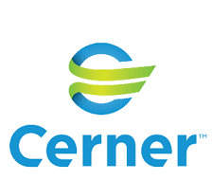
Cerner Corporation is a supplier of health information technology (HIT) solutions, services, devices, and hardware. As of April 2015, its products were in use in approximately 18,000 facilities around the world, and the company had about 22,000 employees globally.
According to KLAS, as of the end of 2015, Cerner accounted for 23.7% of the acute care EMR market share.
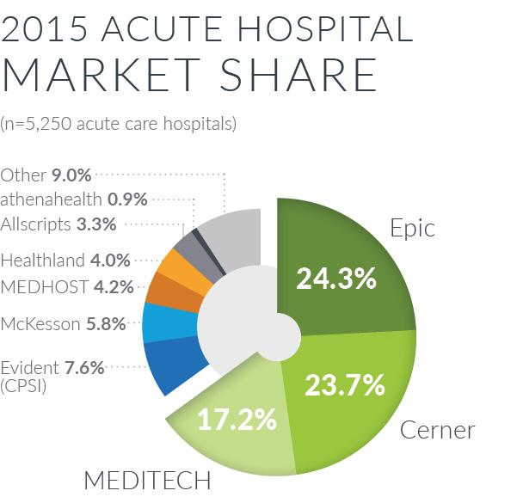
Source: KLAS 2016
They also have just over 12% of the ambulatory EMR market, according to 2015 Peer60 survey.
Cerner’s EMR was highly rated by KLAS for its interoperability, offering strong tools (CEP) for building complex connections and leads out with standards and collaborations. It also offers a standard look and feel across both acute care and ambulatory settings.
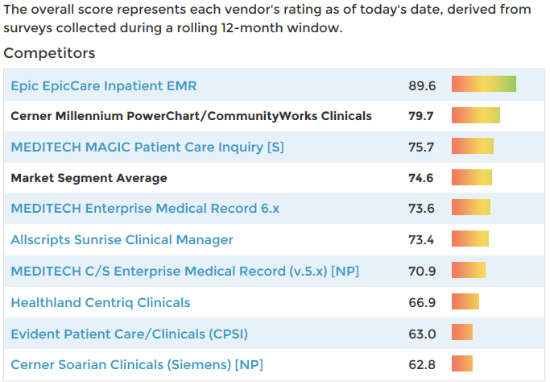
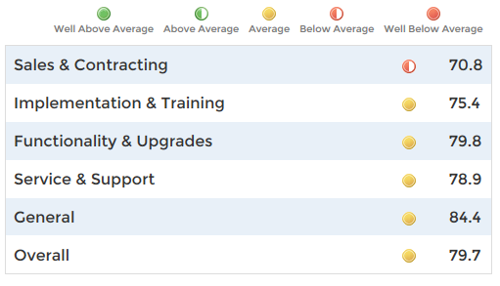
Source: KLAS 2016
In addition to Cerner’s EMR product, they offer solutions for revenue cycle, clinical imaging, ECM, medical devices, pharma, supply chain, workforce management, and hosting services. In February of 2015, Cerner finalized the purchase of Siemens Health Services, the health information technology business of Germany’s Siemens AG, for $1.3 billion. They are also a member of the Commonwell alliance, a not-for-profit trade association with the believes that health data should be available to individuals and providers regardless of where care occurs, and that provider access to this data must be built-in health IT at a reasonable cost for use by a broad range of health care providers.
Despite Cerner’s success, including a 10-year contract awarded in 2015 to overhaul and manage EHRs for the Department of Defense, there have been controversies and litigation along the way. This includes abandoning an electronic records implementation at Girard Medical Center which resulted in a lawsuit, and problematic implementations at Trinity Health and Athens Regional Health System in Georgia, the latter of which was termed a “disaster” leading to the forced departures of the CEO and the CIO of the health system.
In 2016 the Nanaimo hospital ER began using the system. Physicians have called it a "huge failure" with it increasing some types of errors and slowing down the emergency department.

Sources and additional reading:
http://www.cerner.com/
http://www.klasresearch.com/
https://www.peer60.com/wp-content/uploads/2015/01/Peer60-Report-Ambulatory-EHR-2015.pdf

“Trends & Insights in Ambulatory EHR: First Reaction Report” peer60.com. https://www.peer60.com/wp-content/uploads/2015/01/Peer60-Report-Ambulatory-EHR-2015.pdf (accessed June 13, 2016)
“Interoperability 2015: Are We Lifting Together” KLAS.com https://s3.amazonaws.com/assets.fiercemarkets.net/public/004-healthcare/external/KLAS+EMR+Interoperability+Summary+(1).pdf (accessed June 13, 2016)

